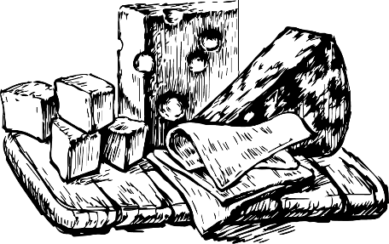


PASCERE AUTUNNO
(Autumn Grazing Menu)
Piatto (Sharing Platters with bread/butter/crackers/chutney) Piccolo Grande 1. Formaggio (Artisan, continental and British cheeses) V £14.95 £24.95
2. Formaggio Blu (Artisan, Blue, continental and British cheeses) V £14.95 £24.95
3. Salumi (Italian & Spanish charcuterie meat) £14.95 £24.95
4. Misto (Italian & Spanish charcuterie meat + continental cheese) £14.95 £24.95
5. Aratore (Ploughman’s with pork pie, ham and artisan cheeses) £14.95 £24.95
6. Vegetariano (Falafel, antipasti, hummus, vegetarian cheese, olives) V £14.95 £24.95
7. Speciale (Selection of the above in a grand platter) - £29.95

Piadina (Flatbread for sharing..or just for yourself!!) 10.5 inch
8. Garlic & Cheese (Flatbread with garlic butter and melted mozzarella) V £ 7.00
9. Margarita (Flatbread with cherry tomato, pesto, mozzarella and balsamic glaze) V £ 8.95
10. Calabrese (Flatbread with nduja, salami, tomato, hot honey, mozzarella) £ 8.95
11. Parma (Flatbread with prosciutto, rocket, peaches, honey & mozzarella) £ 8.95

Spuntino (Small Plates)
12. Hummus (Hummus with flatbread & tortilla crisps) V £8.00
13. Hummus Pesto Verde (Green pesto hummus with flatbread & crisps) V £8.00
14. Caprese Bruschetta (Tomatoes, buffalo mozzarella, lemon, balsamic & olive oil) V £8.00
15. Prosciutto Bruschetta (Prosciutto, buffalo mozzarella, honey & balsamic) £8.00
16. Il Pate Salumi (Ardennes pork/mushroom pate with baguette & chutney) £8.00
17. Polpette (Meatballs with tomato and basil sauce and parmesan) £8.00
18. Formaggio Gustare (Selection of 3 of our finest cheeses with crackers & fruit) V £8.00
19. Salumi Gustare (Selection of 3 charcuterie meats with baguette & chutney) £8.00
20 Vegetariano Gustare (Selection of vegan falafel and pakora with sweet chilli jam) Vg £8.00
Piccolo Spuntino (Small Snacks)
21. Olive Verdi (Bowl of green olives) Vg £3.00
22. Pane e Burro (Extra Bread & Sea Salted Butter) V £3.95
23. Assorted Crisps from the Bar V £2.00

We apologise that due to the method of food preparation we are unable to guarantee allergy requests. If you have any dietary requests or allergies please advise your server
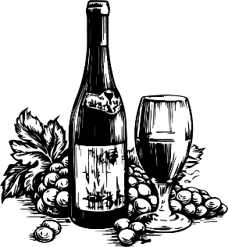
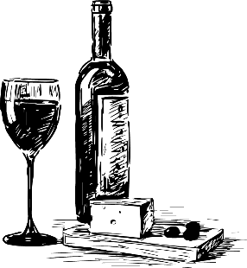
WINES & BEERS

WHITE Bottle 125ml 175ml 250ml
Ombrellino Pinot Grigio £21.00 £4.50 £5.50 £7.50
Wild Ocean Chardonnay £23.00 £4.50 £6.00 £8.50
Lua Nova Vino Verde £24.00 £5.00 £6.50 £8.50
Conde de Castile Rioja Blanco £26.00 £5.00 £7.00 £9.00
Fernlands Sauvignon Blanc £28.00 £5.00 £7.50 £10.00
Gavi di Gavi £30.00 - - -
Macon Villages La Cave £32.00 - - -
Vina Albali Sauvignon Blanc 0.5% £20.00 £4.50 £5.50 £7.00

RED Bottle 125ml 175ml 250ml
Languore Sangiovese £21.00 £4.50 £5.50 £7.50
Five Ravens Pinot Noir £22.00 £4.50 £6.00 £8.00
Lua Nova Lisboa £24.00 £5.00 £6.50 £8.50
Mozzafiato Primitivo £26.00 £5.00 £7.00 £9.00
Apericena Appassimento £27.50 £5.00 £7.50 £9.50
Quid Pro Quo Malbec £29.00 £6.00 £8.00 £10.00
Esprit de Lussac St Emillion £34.00 - - -
Vina Albali Cabernet Sauvignon 0.5% £20.00 £4.50 £5.50 £7.00

ROSE Bottle 125ml 175ml 250ml
Bel Canto Pinot Grigio Blush £21.00 £4.50 £5.50 £7.50
White Zinfandel £22.00 £4.50 £6.00 £8.00
Nicholas Rouzet Provence £28.00 £5.50 £7.50 £10.00
M de Minuty Provence £32.00
Vina Albali Garancha Rose 0.5% £20.00 £4.50 £5.50 £7.00

SPARKLING Bottle 125ml 175ml 250ml
Bel Canto Prosecco (200ml) £8.00 - - -
Bel Canto Prosecco £25.00 - - -
Graham Beck Brut £39.00 - - -
House Champagne £45.00 - - -
Taittinger Brut Reserve Champagne £75.00 - - -
BEERS & CIDERS Half Pint Bottle
San Miguel (5%abv) Draught £2.90 £5.40
Brooklyn Stonewall IPA(4.6%abv) Draught £3.00 £5.80
Guinness (4%abv) Surger - £5.75
Peroni/Red/Corona/Asahi/Madri/Various £4.00 (330ml)
Black Sheep Ale (4.40%abv) £5.40 (500ml)
Old Speckled Hen/Doom Bar (5.0% abv) £5.40 (500ml)
Koppaberg Mixed Fruit/Strawberry & Lime/Magners £5.00 (500ml)
Alcohol Free
San Miguel / Estrella 0% £4.00 (330ml)
Erdinger 0% £5.00 (500ml)
Koppaberg Cider 0% £4.50 (500ml)

